Deprecated Functions
Identify Functions Procedure

Revision
Version 3
2/26/26 7:47 AM

SME
Charles Wilson

Abstract
This document describes the procedure used to perform the function identification activity described in the AVCDL ^{[1]} secondary document Currently Used Deprecated Functions Document ^{[2]}.

Group / Owner
Development / Software Developer

Motivation
This document is motivated by the need to document and justify the use of deprecated functions in the development of software for use within safety-critical, cyber-physical systems.
Note: Within the context of this document, the terms security and cybersecurity are used interchangeably. It is presumed that the term security is being used in reference to cybersecurity and not physical security.

License
This work was created by Torc Robotics and is licensed under the Creative Commons Attribution-Share Alike (CC BY-SA-4.0) License.
https://creativecommons.org/licenses/by/4.0/legalcode

Audience
The audience of this document is the cybersecurity SME who will be identifying deprecated functions.

Completeness of Output
Since the identification of deprecated functions is an as-is analysis, it is critical to ensure that the information gathered is as accurate and complete as possible. All information should be sourced from authoritative sources.
When information is not available for either a given section of the template or parts thereof, this should be noted. Major omissions should be recorded in the cybersecurity risk register.

Disposition of Output
Once completed, the generated output should be managed in the organization’s document management system (DMS) as a document of record.

Entry Criteria
This document assumes that the reader understands the purpose of cybersecurity-relevant function deprecation. Further, that the reader has read and understood the Currently Used Deprecated Functions Document AVCDL secondary document.

Prerequisites – Security SME

Qualifications
It is required that the security SME is both qualified and trained in the handling of deprecated functions.
Note: The specific qualifications and training necessary to assert this expertise is outside the scope of this document.

Knowledge
It is required that the security SME have expertise in the programming language under consideration whose deprecated functions are being reviewed.

Prerequisites – Input Materials
It is required that the cybersecurity SME acquire all relevant documentation related to the programming language under consideration necessary to complete the procedure.

Identify Functions Activity
The workflow diagram for the identify deprecated functions activity of the deprecated functions process is shown below.
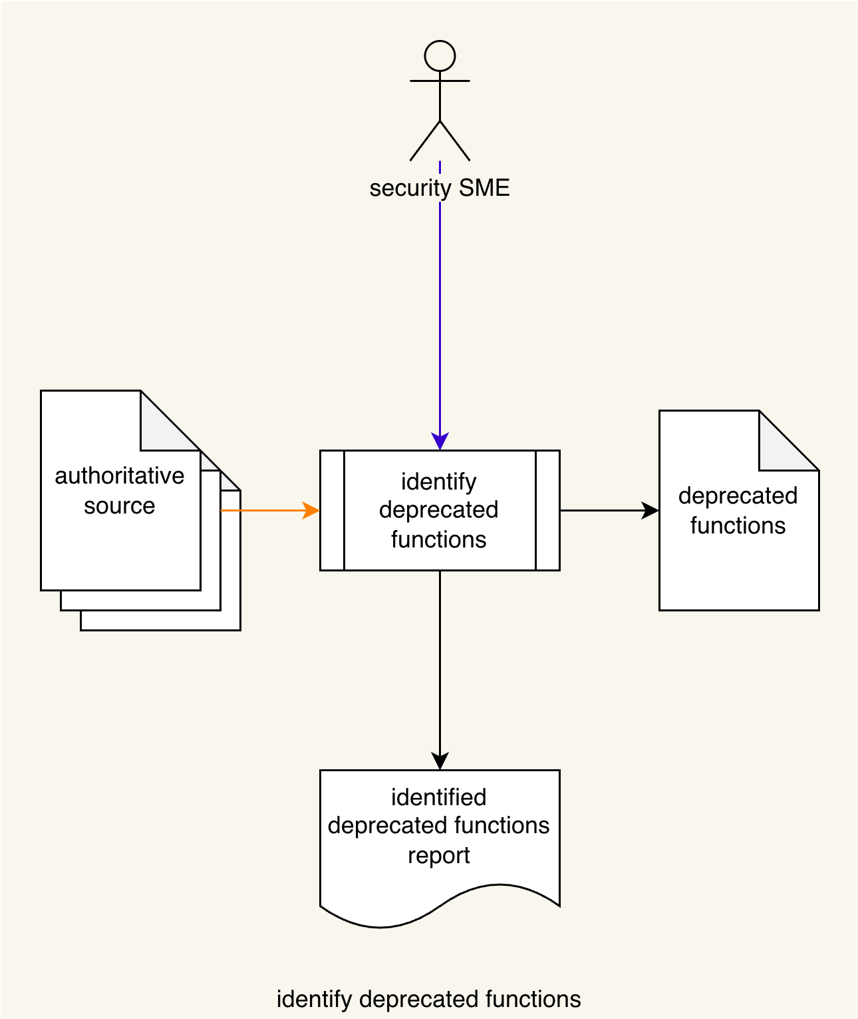
The Security SME reviews the Authoritative Sources to identify functions which have been deprecated. These are entered into a Deprecated Functions list. An Identified deprecated Functions Report is generated.
Note: Deprecated functions should be considered on a per programming language basis.
The Authoritative Source material may include, but is not limited to:
- Technical standards
- Best practices
- Industry recommendations

Methodology
The methodology for this activity is straightforward.
All available documentation is reviewed and a list of deprecated functions is assembled.
Note: It is important to include all deprecated functions, even those which may not be applicable to specific products. Later activities will tailor the list to those which are deemed appropriate.

Deprecated Function Catalog Template
The deprecated functions may be documented using the AVCDL deprecated function catalog template Microsoft Excel workbook ^{[3]}.
Note: Other forms of documentation are permissible so long as they provide the information laid out in this document.
There are four sheets in the workbook. They are:
- Cover sheet
- Revision history
- Reference documents
- <Category>
These will be addressed in turn.

Duplication of Rows in the Various Sheets
When there is the need to add rows to the various sheets of the workbook, be sure to duplicate an existing row. This is because validation checks may be attached to some of cells enabling the use of dropdown lists.

Cover Sheet
The cover sheet of the workbook is shown below:
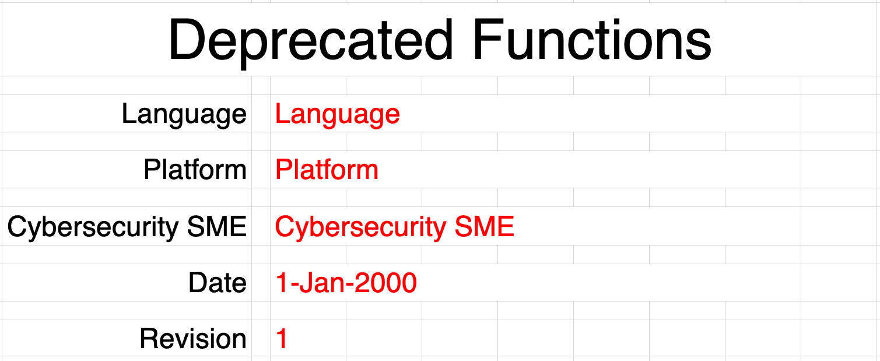
Fields to be completed are shown in red.

Language
This is the programming language under consideration.
Note: Only one language should be considered per file.

Platform
This is platform on which the language is used.
Note: In cases where the language has no platform specific considerations, “any” should be used.

Cybersecurity SME
This is the cybersecurity subject matter expert creating the list.

Date
This is the date when the list was created or updated. The date should be updated whenever the list is updated.

Revision
This is the revision number of the document. The revision number is a monotonic and increasing integer, starting at 1. It should be incremented every time the document is updated.

Revision History
The revision history sheet of the workbook is shown below:
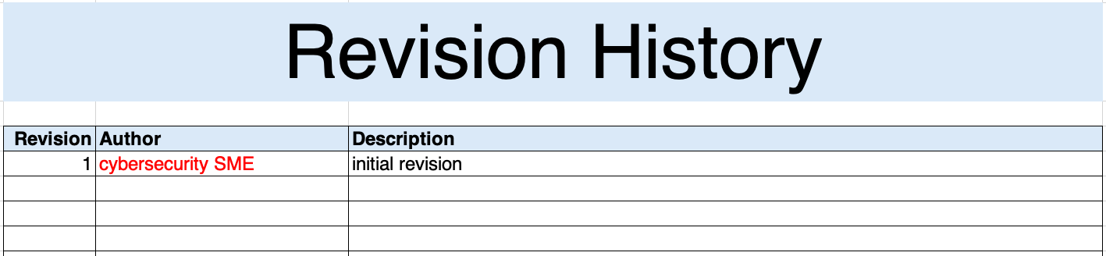

Revision
The revision corresponds to that listed on the cover sheet.

Author
The author corresponds to the cybersecurity SME listed on the cover sheet.

Description
This is a brief description of changes made to the workbook since it was last updated.

Reference Documents
Note: These references are those necessary for the creation of the cybersecurity options list.
The references sheet of the workbook is shown below:
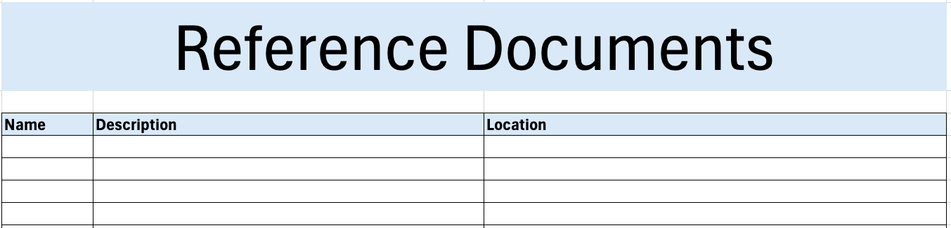

Name
This is the name of the document being referenced.

Description
This is a brief description of the document being referenced.
Note: In cases where the reference material is expressed in the form other than a document (for example, a web page), this should be noted.

Location
This is the location of the document being referenced. It may be a physical location or a URL.

<Category>
The category sheet of the workbook is shown below:
Note: The name of the sheet and header should be replaced with the actual category of function. Some example categories are memory, format, string, and time.
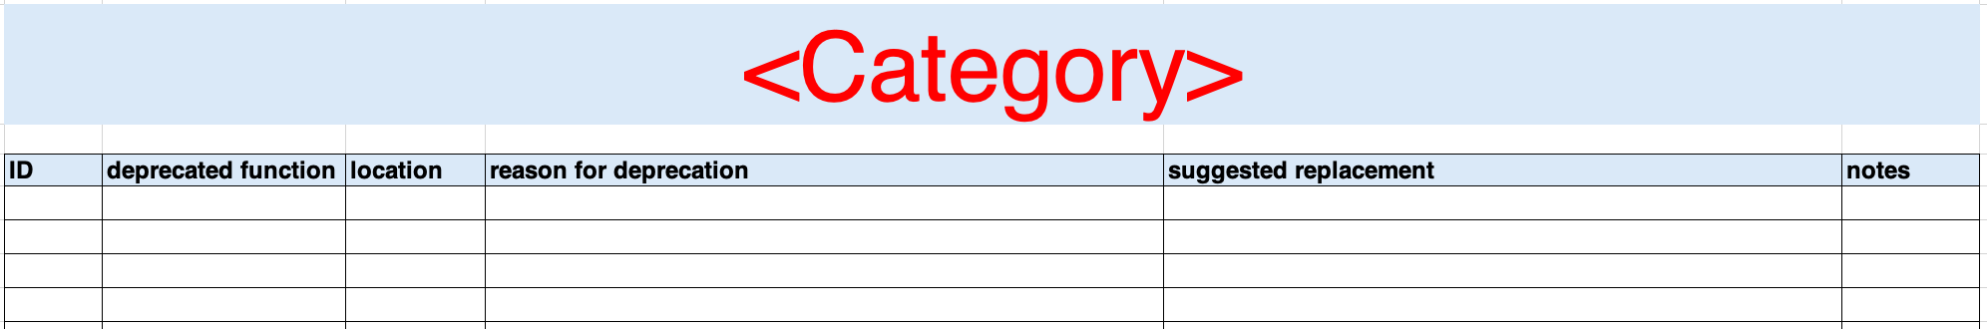

ID
This is the unique ID of the option.
Note: An ID of the form DF<LANGUAGE>-<zero-leading number> is recommended. For example: DFCPP-05.

Deprecated Function
This is the name of the function.

Location
This is the header containing the function.
Note: When the programming language under consideration does not utilize header files, the source file location should be used.

Reason for Deprecation
This field describes why the function has been deprecated.

Suggested Replacement
This is the replacement function or mechanism.

Notes
This is a general notes field.
Note: When multiple notes entries contain the same information, create a two column note reference section below the table (note / information), and giving a monotonically increasing number to each. Use that number in the notes field.

Identified Deprecated Functions Report
The Identified Deprecated Functions Report is the human-readable record of the activity. It is intended to be a standalone document for audit purposes. Its preferred embodiment for storage in the DMS is PDF. The content of the report is that captured in the abovementioned template.
Note: Report generation is covered move extensively in the Report Generation ^{[4]} AVCDL elaboration document.
Note: If possible, it is recommended that the report be generated programmatically.

Exit Criteria
This procedure is considered complete once the generated output has been entered into the organization’s DMS as a document of record.
Note: The processes and procedures for entering documents into the DMS, or the updating thereof, are outside the scope of this document.

References
- AVCDL (AVCDL primary document)
- Currently Used Deprecated Functions Document (AVCDL secondary document)
- AVCDL deprecated function catalog template (AVCDL template)
- Report Generation (AVCDL elaboration document)

